**Test Case** **0004**

**System:** VirtuCardsClient & VirtuCardsHost

**Description:** Tests that the client can draw cards at the press of a button

**Severity:** 2

**Instructions**

**Test 1**

1. Start VirtuCardClient application
2. Click the button labeled “Sign In”
3. Enter “virtucards01@gmail.com” into the text input labeled “Enter email…”
4. Enter “Testing1” into the text input labeled “Enter password…”
5. Press the button labeled “Login”
6. A window should appear saying “Login Success”
7. Press the OK button that appears on that window
8. Start VirtuCardHost application
9. Repeat steps 2-7 but on the VirtuCardHost application
10. The checkbox “Allow Host to Join” should be checked on the host
11. Press the Create Game button
12. In the VirtuCardClient application enter the 6-character room code found on the host’s screen into the field labeled “Enter Code…”
13. Press the Join Game button on the client
14. After the name TestCase0001 appears in the player list on the host side, press the Start Game button
15. After the client side has loaded into the game screen, the Draw Card button should be clickable
16. Press the Draw Card button

**Expected Result:** A new card should be added to the card carousel.

**Before Draw Card Pressed After Draw Card Pressed**

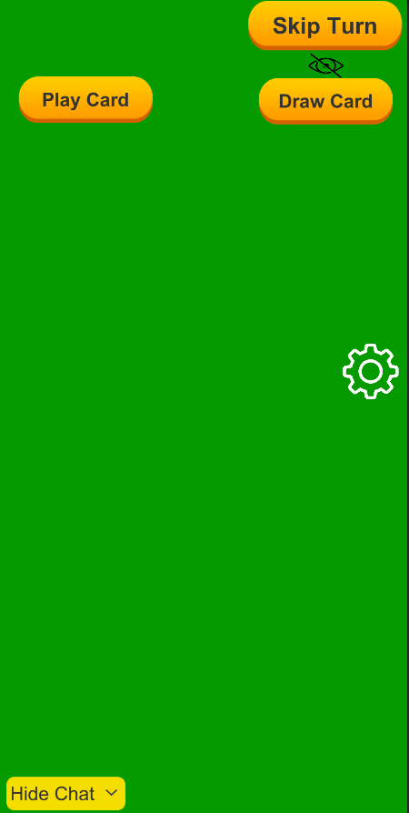 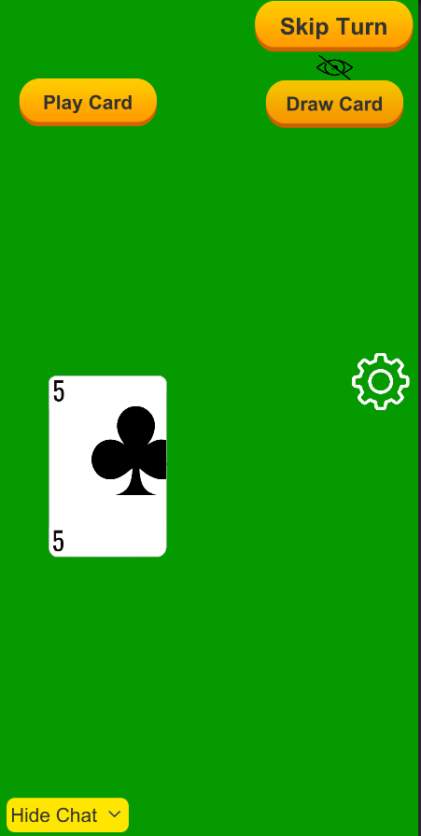

**Test 2**

1. Start VirtuCardClient application
2. Click the button labeled “Sign In”
3. Enter “virtucards01@gmail.com” into the text input labeled “Enter email…”
4. Enter “Testing1” into the text input labeled “Enter password…”
5. Press the button labeled “Login”
6. A window should appear saying “Login Success”
7. Press the OK button that appears on that window
8. Start a second VirtuCardHost application
9. Repeat steps 2-7, but use “virtucards02@gmail.com” as the email and use “Testing1” as the password.
10. Start VirtuCardHost application
11. Repeat steps 2-7 but on the VirtuCardHost application
12. The checkbox “Allow Host to Join” should be checked on the host
13. Select the option “Freeplay” from the game choices
14. Press the Create Game button
15. In the first VirtuCardClient application enter the 6-character room code found on the host’s screen into the field labeled “Enter Code…”
16. Press the Join Game button after it has loaded
17. Repeat previous two steps except on the second VirtuCardClient application
18. After the names TestCase0001 and TestCase0002 appear in the player list on the host side, press the Start Game button
19. After the clients have loaded into the game screen, the Draw Card button should be interactable for one of the players, press it on that one.

**Expected Result:** A random card should be added to that client. A card should not be added to the other client.

**Client 1 Before Draw Card Pressed Client 1 After Draw Card Pressed**

** **

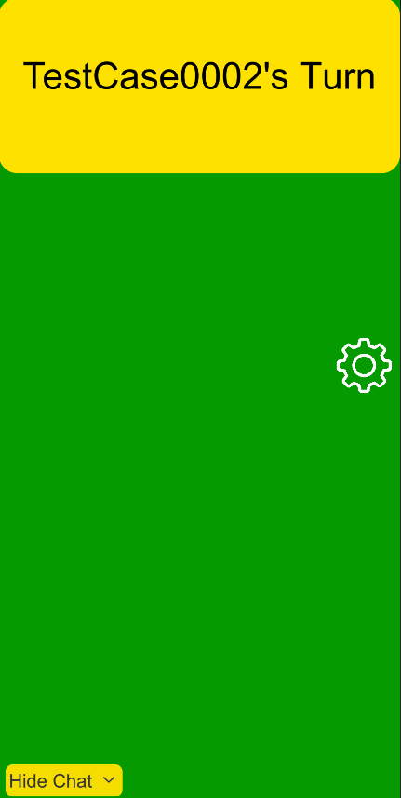**Client 2 Before and After Draw Card Pressed on Client 1**

**Test 3**

1. Start VirtuCardClient application
2. Click the button labeled “Sign In”
3. Enter “virtucards01@gmail.com” into the text input labeled “Enter email…”
4. Enter “Testing1” into the text input labeled “Enter password…”
5. Press the button labeled “Login”
6. A window should appear saying “Login Success”
7. Press the OK button that appears on that window
8. Start a second VirtuCardHost application
9. Repeat steps 2-7, but use “virtucards02@gmail.com” as the email and use “Testing1” as the password.
10. Start VirtuCardHost application
11. Repeat steps 2-7 but on the VirtuCardHost application
12. The checkbox “Allow Host to Join” should be checked on the host
13. Select the option “Freeplay” from the game choices
14. Press the Create Game button
15. In the first VirtuCardClient application enter the 6-character room code found on the host’s screen into the field labeled “Enter Code…”
16. Press the Join Game button after it has loaded
17. Repeat previous two steps except on the second VirtuCardClient application
18. After the names TestCase0001 and TestCase0002 appear in the player list on the host side, press the Start Game button
19. After the clients have loaded into the game screen, the Draw Card button should be interactable for one of the players, press it on that one.
20. Press the Skip Turn button on the same client that drew the card.
21. After the turn has been passed to the second client, press the Draw Card button on the second client.

**Expected Result:** Each client should have a single random card, and the turn should be on the second client.

**Client 1**

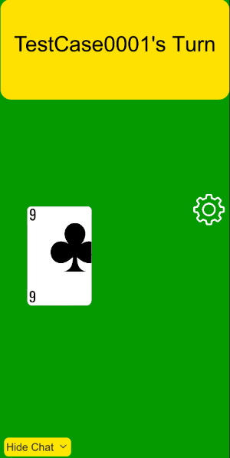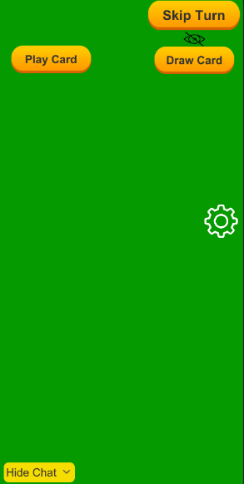 **Before After Draw Card and Skip Pressed**

**Client 2**

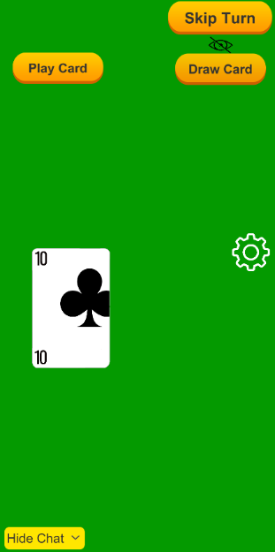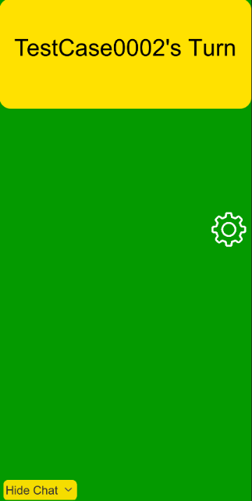**Before After Client 1 Skipped and Draw Card Pressed**

**Test 4**

1. Start VirtuCardClient application
2. Click the button labeled “Sign In”
3. Enter “virtucards01@gmail.com” into the text input labeled “Enter email…”
4. Enter “Testing1” into the text input labeled “Enter password…”
5. Press the button labeled “Login”
6. A window should appear saying “Login Success”
7. Press the OK button that appears on that window
8. Start VirtuCardHost application
9. Repeat steps 2-7 but on the VirtuCardHost application
10. The checkbox “Allow Host to Join” should be checked on the host
11. Select the option “Freeplay” from the game choices
12. Press the Create Game button
13. In the first VirtuCardClient application enter the 6-character room code found on the host’s screen into the field labeled “Enter Code…”
14. Press the Join Game button after it has loaded
15. After the name TestCase0001 appears in the player list on the host side, press the Start Game button
16. After the client has loaded into the game screen, press the Draw Card button
17. Press the Draw Card button again

**Expected Result:** The client should have 2 cards.

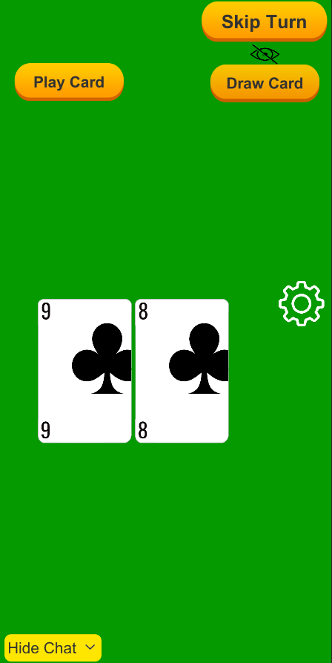**Client Before Client After Drawing 2 Cards**